Good, Bad, and Ugly Goods

So, once again, I decided to learn a little more about how economists see the world. The basic ingredients of their studies center on two pieces: goods and services; and the transactions and behaviors whereby they are produced, traded, and consumed. Many of my past blogs have dealt with the behavioral aspect so it seemed reasonable to ponder a bit more at just what the term ‘goods’ means (obviously expanded to include tangible items like cars and intangible items like tax preparation services).

And so off I went on a rambling intellectual walk-about through a variety of sources, both written ones, collecting dust in my home library, and virtual ones, collecting cyber-dust somewhere in the great digital repository that we all casually call the net.

I held one goal close enough to my heart that its achievement would fill me with satisfaction for a time, but far enough away that its failure would not disappoint. I greatly want to understand how the classical economist ever embraced the clearly flawed idealization of a rational consumer/actor. People rarely act rationally if, by rationally, we mean the narrow concept that they seek material gain as the primary, or perhaps even only, aim. The Ultimatum Game being one of the surest refutations of that position. Certainly I am mindful that all disciplines need approximations and idealizations to progress but at what point did the idealization cease being a model and started to become gospel was the question. Perhaps the answer lay in how economists look at the goods people produce, trade, and consume.

I wasn’t really expecting an answer but I would have liked to have even a hint. Alas, even a hint was too much to ask but I did learn some interesting things about goods that is worth at least a few more paragraphs. In short, there are three categories that, with apologies to Sergio Leone, I call good, bad, and ugly goods. Economists, of course, don’t call them that, but their categories match mine quite closely so I’ll not be shy in using my lingo interchangeably with theirs.

Good goods are what are generally termed ordinary goods by economists. An ordinary good possesses a negatively sloped demand curve. As the price of the good rises, there is less consumption of it as consumers seek out substitutes and alternatives. A substitute is a good that serves the same function but costs less. Switching out Bombay Sapphire for Beefeater is the kind of switch that economists mean by the term ‘substitution’ although they, no doubt, would never stoop so low as to buy a lesser gin. In contrast, giving up gin and tonics permanently in favor of tea-totaling falls under the heading of ‘alternative’. In either case, the consumer generally responds to an increase in price by changing their behavior so that they consume less when the vendor asks more.

Good goods further sub-divide into three categories called: inferior, normal (or necessary), and luxury. This sub-categorization reflects the natural evolution in most consumers that, as their income grows, they themselves grow accustomed to better styles of living. I borrowed this latter terminology from the divorce court lawyers who argue that their client is entitled to alimony that supports the client in the style to which the client has become accustomed. Levity aside, each category reflects the income elasticity of demand of a good found within its bounds. Economists define income elasticity of demand as the ratio between the percentage change in the quantity demanded to the percentage change in the household income.

As a person’s income grows his fractional change in income is positive. If he decides that he no longer needs to eat ramen noodles every night because he now has enough money to go out for a burger from time to time, then the fractional change in ramen demand is negative. The ratio between the two is also negative and the good is inferior. More simply put, as a person’s grows his need to settle for a good he would otherwise not buy diminishes. Thus ramen is an inferior good.

Normal and luxury goods have positive elasticity, meaning that the quantity demanded typically grows as income grows. The difference between these types of goods lies the magnitude of the elasticity. An elasticity less than one means that changes in income do little to change the quantity of the good demanded whereas an elasticity greater than one means that a small change in income (or in a related fashion price) makes a big change in the amount demanded. Normal good fall into the former category (as a result they are sometimes called necessities) and luxury goods fall into the latter. Food is typically a normal good and the consumer will buy his staples, say a gallon of milk, each week essentially regardless of the price or his income. Fine gin is regarded by many as a luxury item (although it shouldn’t be); to be bought when the price is right or the take home pay is sufficient to allow an indulgence.

In deference to any actual economists who may read this, I do want to be clear that in the last paragraph I played fast and loose and blurred the distinction between income elasticity of demand and price elasticity of demand. They are distinct but highly-interrelated concepts, ultimately connected in a much broader definition of personal value. Here I am imagining something like elasticity defined as the ratio of percentage change in demand to percentage change in the percent of the household expenditure buying the good represents. A professional can either work that concept out in detail or prove/argue why it can’t work – it won’t change the fact that each of us weighs the demand for a good by more than the change in price or in income, all other things held constant.

Bad goods are what economists call Giffin goods. These goods defy the law of demand in that their demand curve is upward sloped. As the price increases so too does the demand. The big brains claim a Giffen good is typically

* + an inferior good
  + does not have easily available substitutes
  + purchase of it must be a substantial fraction of the total household expenditure meaning that the good is purchased only due to the limited income.

The oft-cited Giffin good example is a staple food depended upon by the poor. As its price rises, additional income used to buy other goods becomes slimmer and the household is forced to buy more of the cheaper but price-rising good just to be able to eat. In the example above, if ramen increases in price, our hypothetical burger-muncher may have visit Five Guys less often because he has to sink more of his income into ramen just to have something to eat each day. Sir Robert Giffen claims to have seen this behavior in Victorian England but certain economists assert that [there is no such thing](http://www.investopedia.com/terms/g/giffen-good.asp).

The ugly good is synonymous with what economists call a Veblen good. Like the Giffen good, demand for a Veblen good rises as its price rises. However, the rise in the demand reflects the good as a status symbol showing that the purchaser is truly a king among men in that he can afford more of what others can’t afford at all. Conspicuous consumption, which is another name for the kind of behavior that supports a Veblen good, is featured prominently in the rather amusing first part of Chesterton’s *The Queer Feet* and the reader is directed here for a nice quote.

So there you have it. A concise, if not precise, summary of how economists categorize goods and their corresponding elasticities. It would be an interesting follow-up to see if their analysis, papers, and books, which are goods in and of themselves, are good, bad, or ugly.

Frames and Systems of Reference

Thinking about other points-of-view is a proven strategy for more clearly defining what a concept is and what it isn’t. The heart of the Socratic Method involves repeatedly changing perspectives along this line. Each dialog employs an operational approach roughly rendered as ‘yes, suppose we look at the matter with this definition, what do we find’. Following this line of questioning diligently and in a disciplined manner strips away more of the accidentals and allows a sharper picture to emerge of the essential nature of the idea in question.

Such an approach is also useful for sharpening the thinking involved in modeling physical or mathematical objects. Steps forward in science, particularly physics, comes about often from a cleaner definition of just what some primitive object involves.

Oddly enough, I had the good fortune to be involved in two separate and unrelated discussions this past week about the essential natures of the points-of-view used to describe the physical world, which, in the physical sciences, are always referred to as reference frames or coordinate systems or some closely similar phrasing. The resulting dialogs certainly helped me to see better what the physical sciences really know about frames and systems of reference.

To set the stage, a disclaimer is in order. As far as I can tell, there is no universal agreement about how to define a reference frame, or how, exactly, it differs from a coordinate system and the associated measurements. This lack of uniform definition points to some deep issue – either epistemological or ontological – about the nature of space and time and how humans perceive these things. One part of the reason seems to be that the operational concepts are so primitive that we have only a basic notion, in many cases, of how to describe it. I liken it to being able to drive a car or ride a bike but yet be unable to describe how to do these things to someone who can’t. But I think that there is an even bigger reason that speaks to how we divide the world up into categories and how we identify the essentials from the accidentals.

To make this last point clearer, let me concretely discuss my definitions of reference frame and coordinate system and then point out how one may logically use these definitions to come up with something akin to a contradiction.

A reference frame is a physical object possessing a point-of-view. The prototype is the human being so defined to have the essential parts of a set of limbs to move about, eyes to look, a mind/brain to process, a mouth to speak the results, and ears to listen. Even when physics speaks about inanimate objects there is, lurking in the background, the notion of what an observer would see were he a disembodied spirit moving along with or sitting upon the object (such is the nature of our imaginations and how we understand the world). A convenient abstraction is that a reference frame is any object that has a definite place, which possesses three (independent) directions that it can use, in combination, to point at something, and which has some measure of scale.

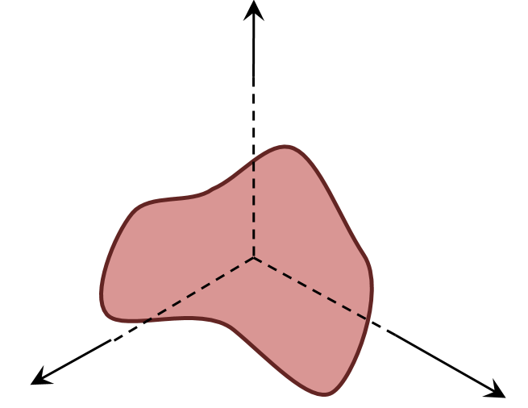

Now suppose something of interest comes into this objects field-of-view. As a reference frame it can point towards the object and can denote how far away the thing of interest is. By convention, our primitive reference frame object will adjust the length of the direction to the thing of interest, making the length of the arrow along the direction longer or shorter in proportion to the distance. Thus we have defined a traditional position vector with respect to our primitive reference frame.

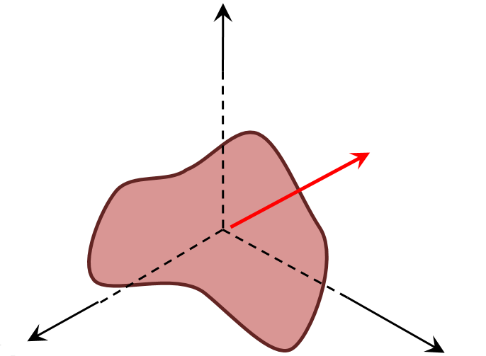

Note that the notions of direction and distance are also primitive concepts with no easy way to define them in terms of other, simpler things. Also note that there are no names for the directions yet nor is there any developed idea of how to specify these directions or distances mathematically.

The next step is to remedy this short coming because being able to measure and compute and reproduce values are vital ingredients to understanding the world. The remedy involves giving the primitive reference frame basic measuring tools. For this discussion, the ruler, the clock, and the protractor will suffice and the generalization to more sophisticated modes shouldn’t be too hard.

Using only rulers, we can decorate the primitive reference frame with a set of planes, each possessing a ruled grid of lines and spaced with a known distance. One such configuration is shown below.



The thing of interest is then specified by the labels specifying on which plane and within which cell is it located. Other objects can be as deftly located and thus we arrive at a coordinate system – an instance of the Cartesian coordinate system to be precise.

Two important things are worth noting. First, in this scheme, the reference frame possesses the coordinate system – we’ll return to this point below. Second, the coordinate system is arbitrary. The planes shown above were oriented so that their edges coincide with the reference frame directions but this choice is no better or worse (at least philosophically) than any other.

Indeed, the whole idea of using planes, regardless of alignment, can be abandoned altogether. Instead, we could have chosen to use concentric spherical shells of different radii with great circles and latitude lines (taken as primitive notions) drawn on them. The protractor is now our tool of choice and the result is the spherical coordinate system. One such shell of one such instance is shown below.



In terms of these shells, the location of the thing of interest would be specified by stating on which shell it lies and by giving the great circle and latitude lines on which it lies. Of course the orientation of the great circles and latitude lines are as equally arbitrary as the alignment of the planes pictured above.

The whole scheme holds up just fine as long as it is being used operationally. The trouble comes when one starts examining it closely with an eye to first principles (yet another point-of-view). Several annoying questions come up which bring into doubt the underlying consistency of the scheme. Some of these are:

* How can the reference frame have a notion of direction and length without first having some notion of how to measure angles and lengths? In other words, which comes first, reference frame or coordinate system?
* What objects are used to find the position and orientation of the first object – are they not also reference frames? There is a Machian idea buried here but no time to worry about that now. It suffices to point out that this ambiguity leads to the perpetual confusion between active and passive rotations.

One might also pose the following question. Since coordinate systems also objects in their own right, with directions determined by lines of constant coordinate value, can’t they also be used as reference frames. My answer to that question is a guarded no. Cartesian coordinates really don’t really have an origin that matters – they are really an affine space – so they aren’t quite the same type of object as the primitive thing we attached directions and an origin to. This observation is also not very solid since the spherical coordinate system has to have an origin upon which the spherical shells are centered. Even this requirement doesn’t prevent it the origin from shifting, it just makes the algebra much harder and since most everyone goes back to Cartesian coordinates to compute it isn’t a strong point.

More troubling is the observation that some origins are devoid of a physical object. For example, the barycenter of two equal mass objects separated by a distance great enough that they don’t touch is located in the empty space between them. Nonetheless, scientists are quite happy to use this mathematical construction as an origin of a reference frame.

So in the final analysis we are left with two basic conclusions. First, it is no wonder that there is no uniformly, accepted definition of the basic terms of reference frame and coordinate system. In some sense they are tightly interconnected and too primitive to define precisely. As long as any scheme works (i.e. give the right numbers) it is operationally sound if not totally logically so. Second, by studying this thorny problem, we can get some insight into just what is knowable and explainable.

Do It Yourself Colorist

Walk into any Barnes and Noble bookstore and you’ll find, prominently displayed on a table near the front of the store, a host of adult coloring books and supplies of brush markers. It seems that adult coloring is a new pastime. I’ve tried it and it is a lot of fun. To be clear, I never gave up on coloring the old way (crayons and kids coloring books), so maybe I am bias but whatever.

At first, the only available books featured complex geometric patterns or stylized animal prints or nature scenes – you know… adult things. Fortunately, comics publishers have been jumping on the bandwagon and one can now get coloring books with content ranging from EC’s horror line to everyone’s favorite moral reprobate: Deadpool.

All of that is well and good and I have purchased coloring books of both stripes – sober adult content and cheeky adolescent fare – and have enjoyed coloring in each kind. Up to a point.

Of course coloring the image has its drawbacks. The most notable one is that the original unfilled image is lost forever once you start coloring unless you buy another copy or you photocopy, scan, or otherwise digitally reproduce the original. Personally, I don’t want to indulge in the former and much prefer the reproduction route. But if one is going to do that, why limit oneself to what the publishers deem appropriate. Branch out.

And so that is just what I did. Using a smart phone (or digital camera or a scanner), some photo-editing software, and some of those DC Showcase or Marvel Essentials black-and-white reprint volumes, you can make your own custom coloring book and get started practicing as a do-it-yourself colorist.

For this post, I photographed an image from *Essential Captain Marvel, Volume 2* in which Thanos first reveals that he possesses the cosmic cube. To capture the image, I used Genius Scan on my Samsung Galaxy Note 3 (old but powerful and much beloved). I like Genius Scan since it corrects for some curvature and rotation automatically. The page was in the middle of the volume which is a thick as an old-fashioned phone book from a mid-size city. The raw image looked like this



I then loaded the image into the GIMP and cropped it to

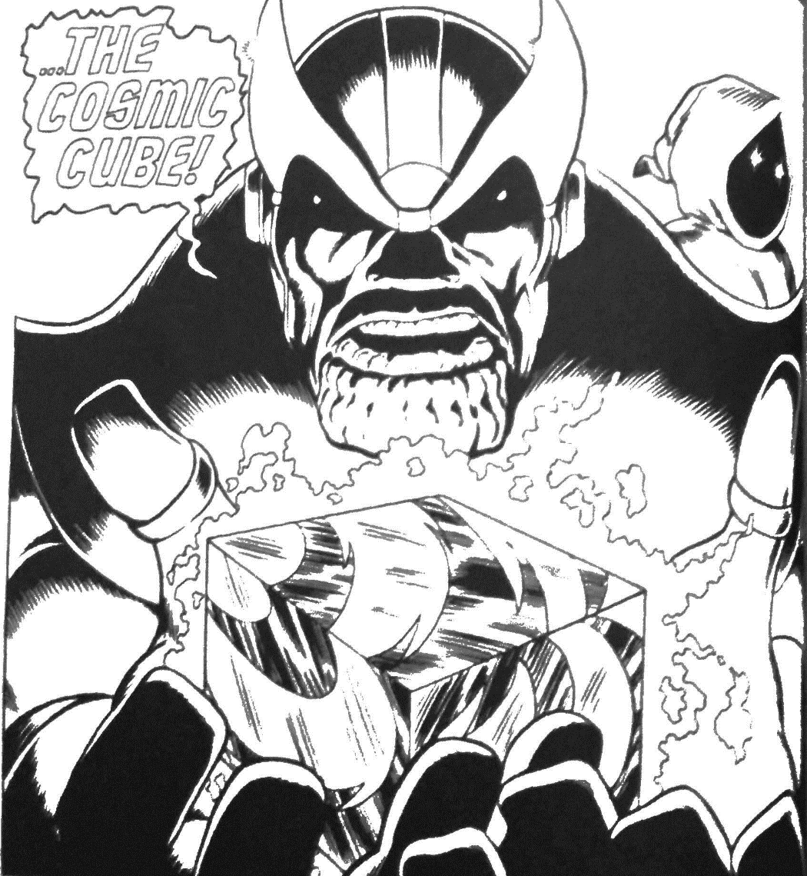

The next step was to start coloring. For this quick and dirty approach I didn’t use layers nor did I try any tools except the bucket fill. This was a bit clumsy as certain regions that looked closed often had small gaps due to either the publisher reproduction, the printing process, or the image capture. Whatever the reason, when a small, undesired gap was present the bucket fill would sometimes over fill as in this image



At times like this, the undo (ctrl-Z) I your friend. Repairs involving the eye-dropper (color-picker) tool and the brush. Simply grab a gray/black from some point nearby and close the gap and color again.

Using this rather primitive process, it only took me about 10-15 minutes to color in the image to

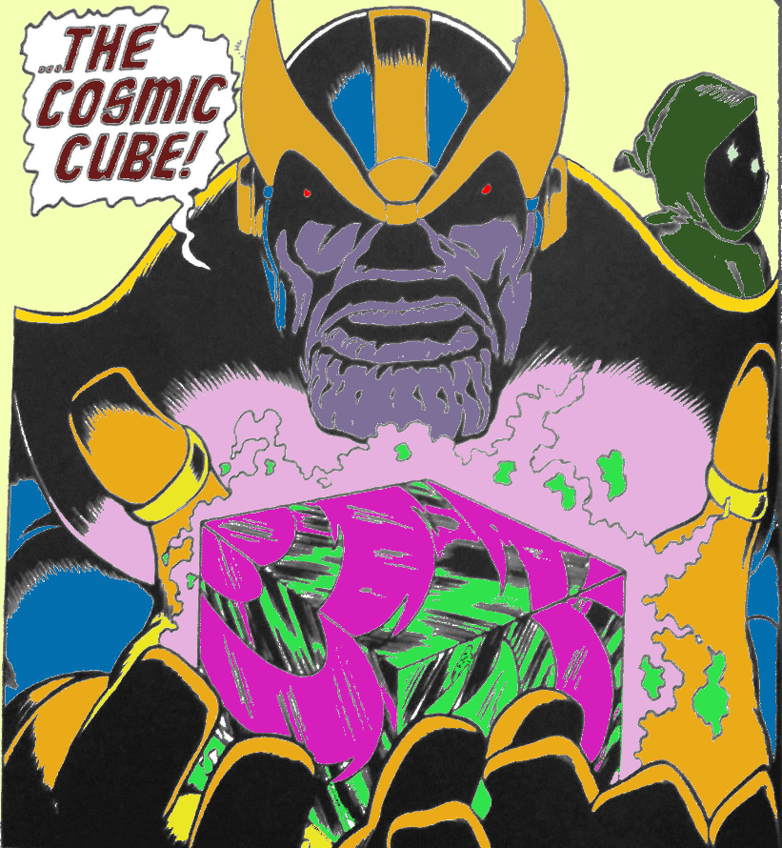

Clearly the image needs work, especially around the crenellated chin of the Big-T. But all, told it didn’t turn out too bad given that layers and brushes and other sophisticated tools were totally ignored.

So there you have it – a three-fold win: 1) a fast way to create your own digital coloring books using your favorite art, 2) a new use/justification for buying the cheap B&W reprint volumes, and 3) a path to learn to be a real colorist without the need to find an artist and inker.